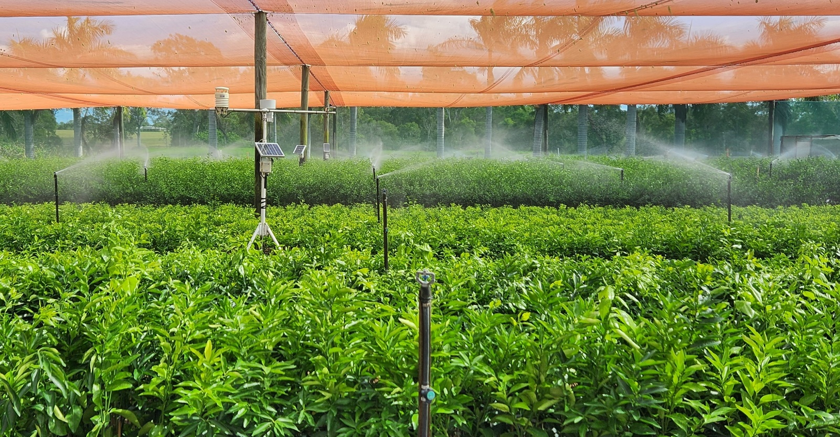
Digital remote monitoring to improve horticultures environmental performance
Smart Farming Virtual Field Day
GIA and project partners Hitachi Vantara and Applied Horticultural Research are presenting a virtual field day on the 2nd of November 2023 to present how smart technologies are helping Golden Grove citrus nursery to manage resource use and increase productivity.
We invite all who are interested in hearing how the sensors and a central control tower is assisting in the daily decision process and the benefits identified to register. Technology discussed include remote sticky trap cameras, water quality sensors, container moisture content monitoring, leachate nutrient monitoring, plant stress sensors, and a water disinfestation sensor.
Register Here

Field day program:
10:00 am – David Hunt, GIA – Welcome and introduction to the Smart Farming project.
10:15 am – Liam Southam-Rogers & Henry Hyde, AHR – An overview of smart farming technologies used
10:35 am – Dallas Gibbs, Hitachi Vantara – The Hitachi Control Tower and Smart farming
10:55 am – Wayne Parr, Golden Grove Nursery – A virtual walkthrough and using smart technologies
11:25am – Celeste Cook, GIA – BMP’s and the benefits of installing Smart Technologies
11:45 – Andrew Chamberlin, Queensland Farmers Federation – Solar micro-grid project for horticulture.
12:05 pm – A general discussion and questions from attendees about integrating smart technologies
12:30 pm – Field Day wrap up and final words.
This project has been funded by Hort Innovation nursery products research and development levy and the Australian Government’s National Landcare program. Hort Innovation is the grower owned, not-for-profit research and development corporation for Australian horticulture.

