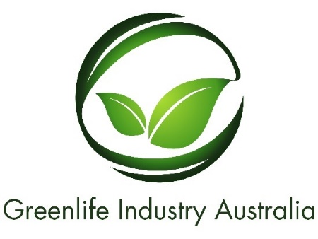

GREENLIFE INDUSTRY AUSTRALIA LIMITED

ABN 59 634 584 017

NOTICE OF ANNUAL GENERAL MEETING

NOTICE IS GIVEN that an Annual General Meeting of members of Greenlife Industry Australia Limited will be held as a Virtual Meeting at 2pm on Tuesday 23rd November 2021

Please join my meeting from your computer, tablet or smartphone:

Greenlife Industry Australia Annual General Meeting
Tue, Nov 23, 2021 2:00 PM - 4:00 PM (AEDT)
Please join my meeting from your computer, tablet or smartphone.
https://global.gotomeeting.com/join/712084573
You can also dial in using your phone.
Australia: +61 2 9091 7603
Access Code: 712-084-573

AGENDA

- President’s welcome.
- Present, Apologies and Proxies.
- Administrative Arrangements.
- Announce and acknowledge obituaries during the past year.
- President’s Report.
- To receive and approve the Audited Accounts and the reports of the Directors and Auditors of Greenlife Industry Australia Limited for the year ended 30 June 2021.
- Appointment of Directors
- Appointment of Auditor for the 2021/22 Financial Year.
- Motions on notice to amend the GIA constitution. (Special Resolutions)
- General business.
- Close of meeting.

By order of the Board

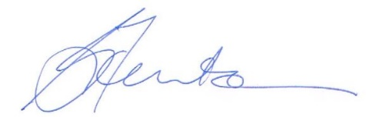

Glenn Fenton

Company Secretary
02 November 2021

All future notices will be by email only, please contact the Company Secretary if you would like to register or request any further information.

